2023 PCCAC
SUMMER ARTS

NAME:____________________

ADDRESS___________________________________________________________________
PARENT(S)_________________________________________
EMAIL:___________________
PHONE:__________((home)
cell)___________(work)______

ALLERGIES/LIMITATIONS: _________________________________________________

DOCTOR_________________
PHONE:_______________
DENTIST________________
PHONE:_______________
EMERGENCY CONTACT:_______________
PHONE: ______________

CLASS:_____________wk(s)__

CLASS:_____________wk(s).__

To be signed by parent(s)/guardian(s)
I understand that PCCAC, its members and/or instructors are not liable for any accidents and/or injuries that may occur at the Calvary Arts Center during any and all programming.

Parent/guardian_____________
Parent/guardian_____________
Date____________________
DEADLINE: POSTMARKED 6/1
CLASSES ARE LIMITED TO 20 PARTICIPANTS ON A FIRST-COME, FIRST SERVE BASIS.
Info: 740-651-5151
Note: Your instructor will contact you “ONLY” if the class is full.
“FREE”
SUMMER ARTS
WORKSHOPS
2023
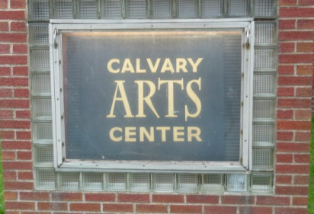
447 S. Main St.
New Lexington
Registration:
Mail to: PCCAC
P.O. 204
New Lexington,
OH 43764
Schools, libraries
on-line: pccac.org
PROGRAM: 8/6 2:00

